Experiment Number: 5

Problem Statement: Implement multithreading for Matrix Operations using Pthreads**.**

NAME: **Anish kamble**  ROLLNO: 55

CLASS: TY(AI-A) BATCH: 3

DATE OF PERFORMANCE: 6/10/22

___________________________________________________________________________

PROGARM: Addition and Subtraction of Matrices

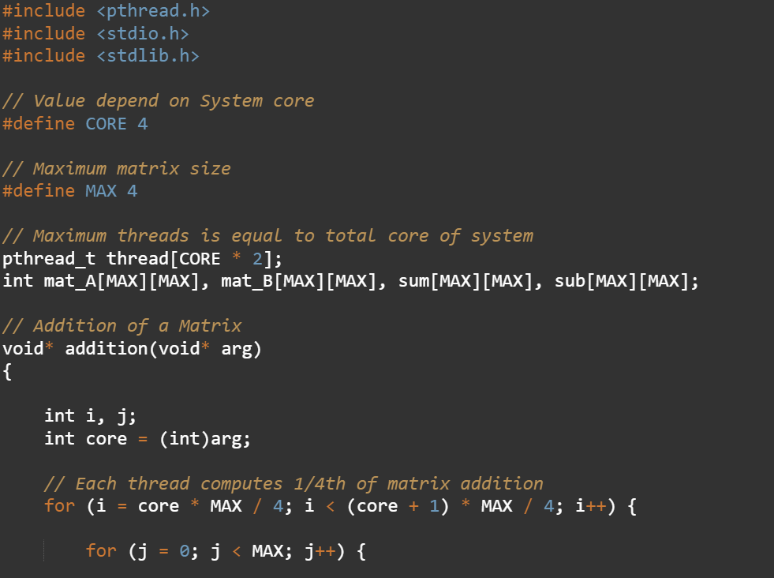

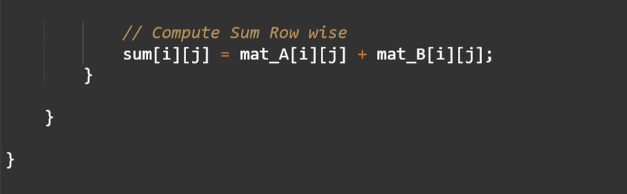

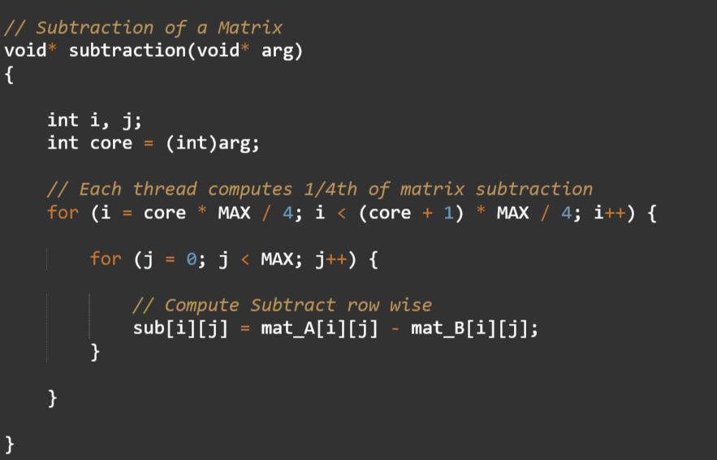

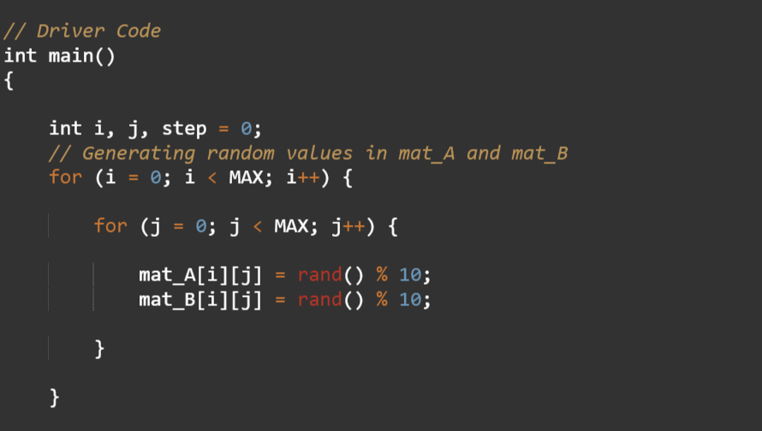

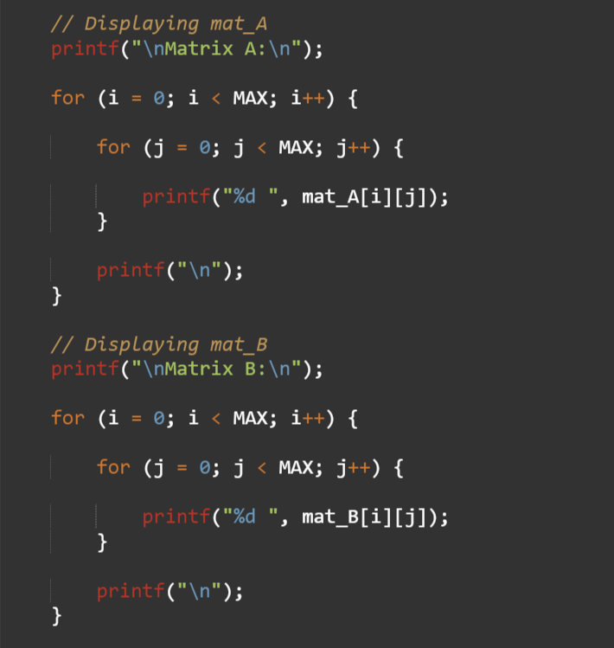

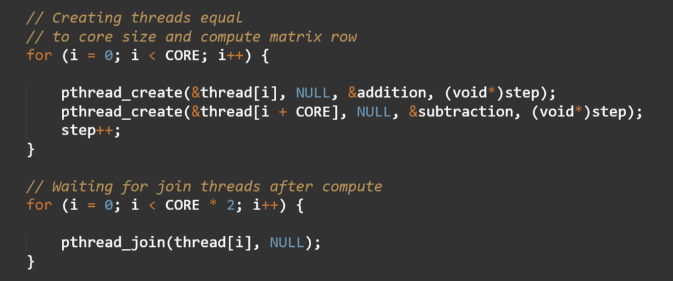

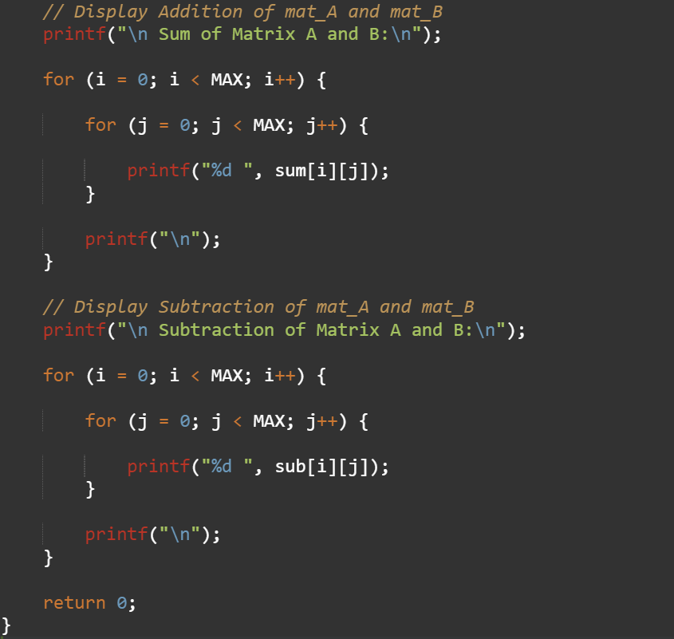

**OUTPUT:**

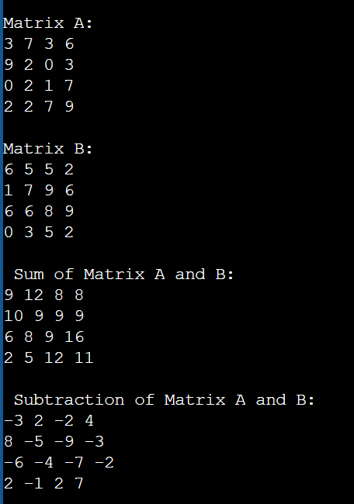

PROGRAM: Multiplication of Matrices.

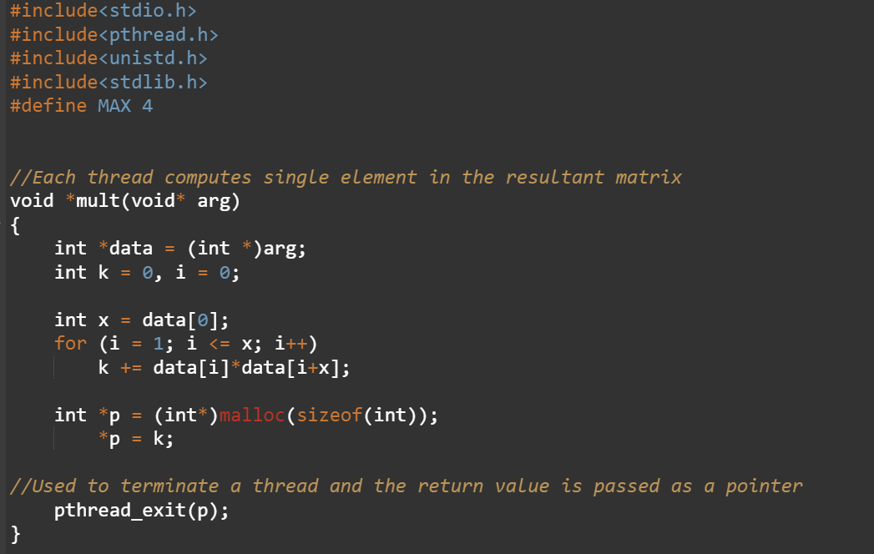

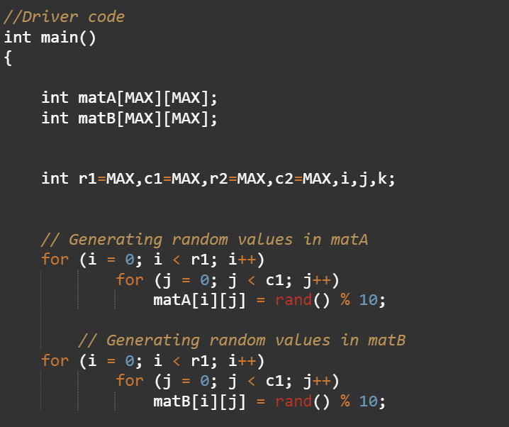

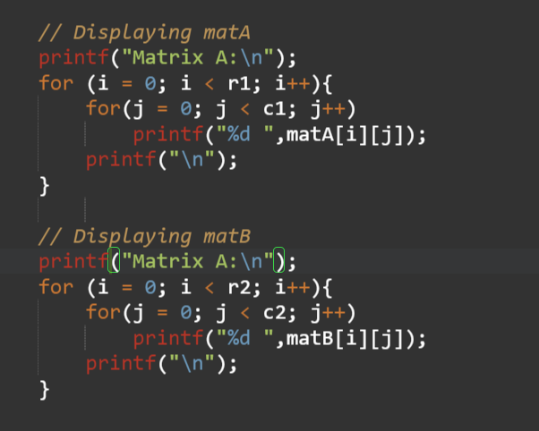

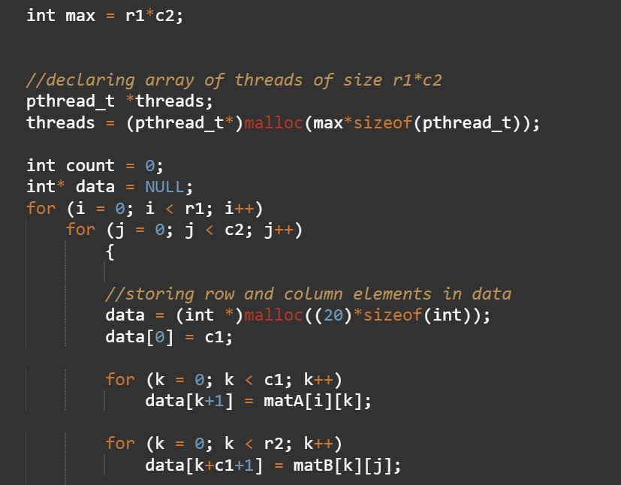

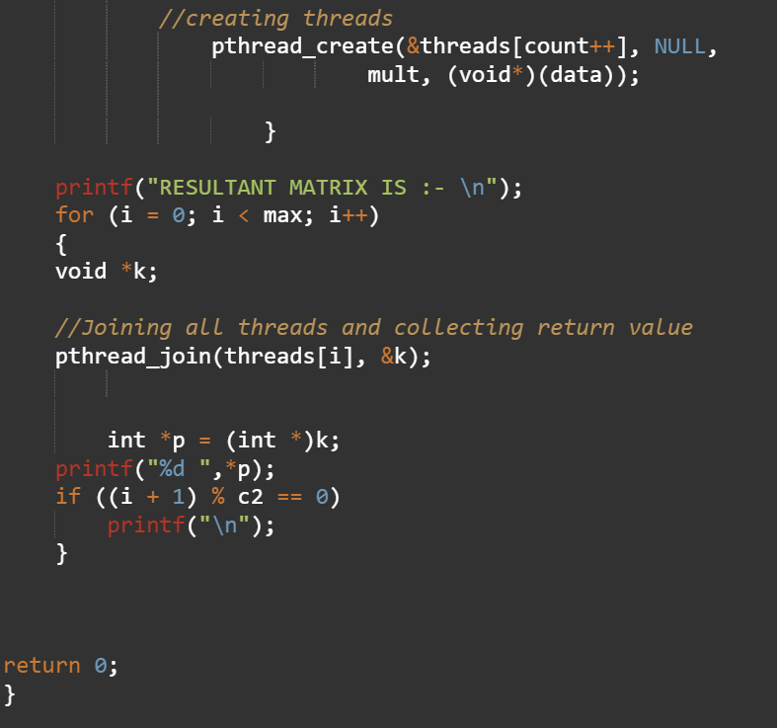

**OUTPUT:**

